|  |  |  |  |  |  |
| --- | --- | --- | --- | --- | --- |
| Project Name: Udemy | | | Test Designed by: Md. Mehedi Hassan Shohan | | |
| Test Case ID: UDM-01 | | | Test Designed date: 08/05/2023 | | |
| Test Priority (Low, Medium, High): High | | | Test Executed by: Md. Mehedi Hassan Shohan | | |
| Module Name: Search Courses | | | Test Execution date: 08/05/2023 | | |
| Test Title: Search Courses from Udemy | | |  | | |
| Description: Test whether the system finds the desired courses from search list . | | |  | | |
| Precondition (If any): User have to signed into the “Udemy” account for search courses . | | | | | |
| Test Steps | Test Data | Expected Results | | Actual Results | Status  (Pass/Fail) |
| 1. Log in to the site 2. Go to the udemy home page 3. Click on “search for anything” 4. Type “ course name” 5. Click on Search | Mobile Number:  01864348314 | User will be find whatever course he wanted from the site. | | As expected, | Pass |
| Post Condition: User will have his desired courses after click on the search button. | | | | | |

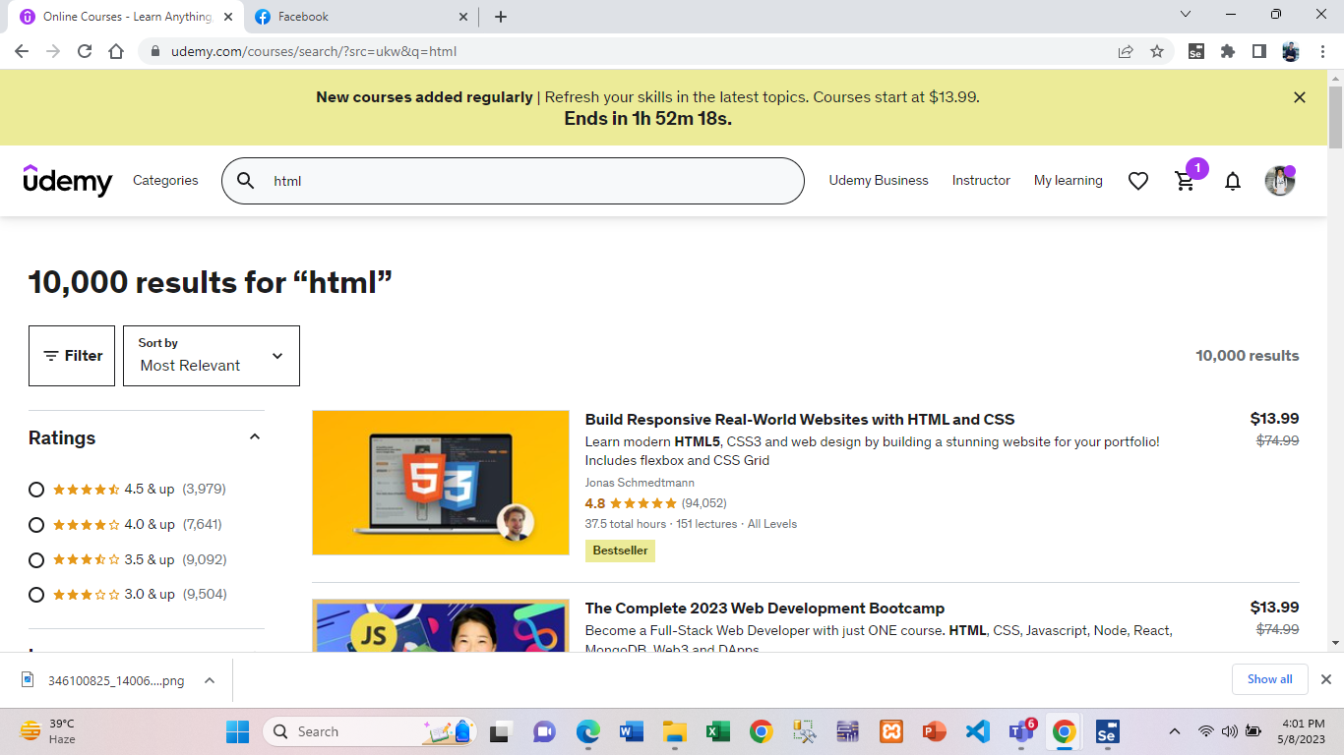

Fig : Search courses test case result

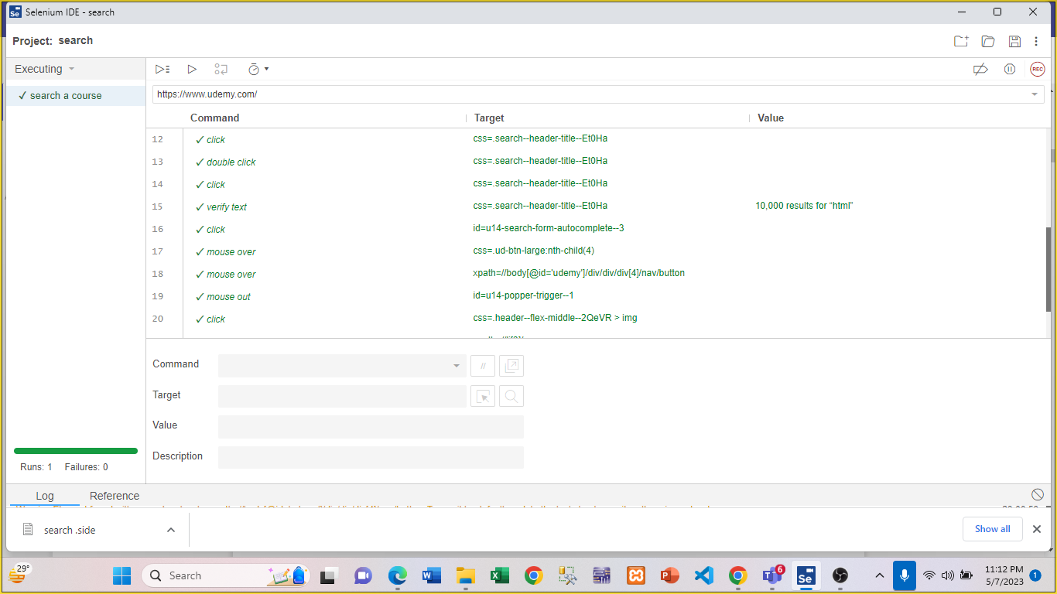

Fig : Search courses test case execution

|  |  |  |  |  |  |
| --- | --- | --- | --- | --- | --- |
| Project Name: Udemy | | | Test Designed by: Md. Mehedi Hassan Shohan | | |
| Test Case ID: UDM-02 | | | Test Designed date: 08/05/2023 | | |
| Test Priority (Low, Medium, High): High | | | Test Executed by: Md. Mehedi Hassan Shohan | | |
| Module Name: Scheduling learning time | | | Test Execution date: 08/05/2023 | | |
| Test Title: Schedule time for learning | | |  | | |
| Description: Test whether the system set the time and date properly . | | |  | | |
| Precondition (If any): User have to signed into the Udemy account for set the scheduling learning time | | | | | |
| Test Steps | Test Data | Expected Results | | Actual Results | Status  (Pass/Fail) |
| 1. Go to the udemy website 2. Click on “MY Learning” 3. Click on “Learning tools” 4. Select the course 5. Click on next 6. Set frequency 7. Set Duration 8. Set time and date . 9. Click on Next 10. Click on “Done” | Mobile Number:  01864348314 | User will be see the notification of the selected time . | | As expected, | Pass |
| Post Condition: User have to fill all the option , which is required for set the time. | | | | | |

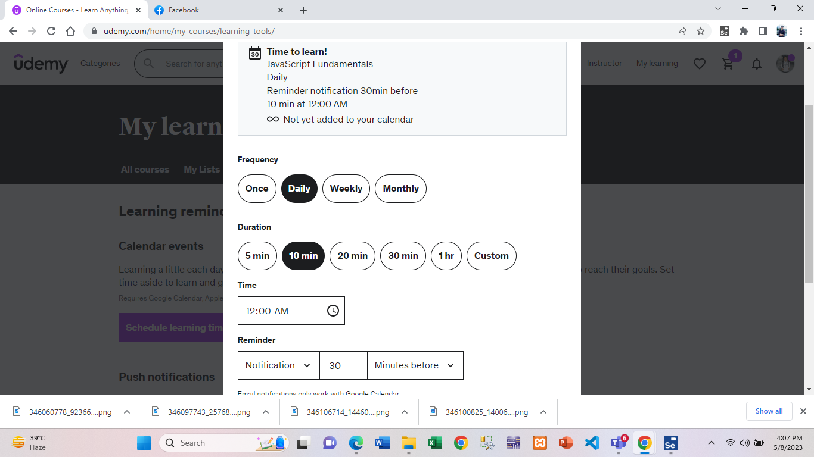

Fig : Scheduling learn time test case result

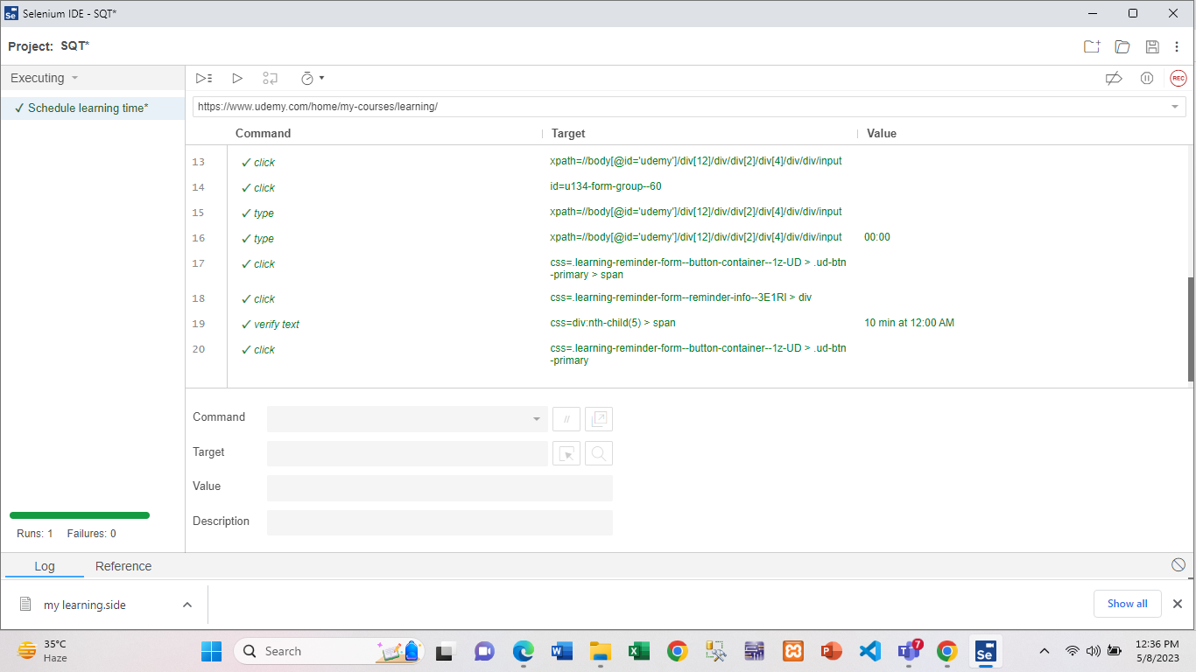

Fig : Scheduling learn time test case execution

|  |  |  |  |  |  |
| --- | --- | --- | --- | --- | --- |
| Project Name: Udemy | | | Test Designed by: Md. Mehedi Hassan Shohan | | |
| Test Case ID: UDM-03 | | | Test Designed date: 08/05/2023 | | |
| Test Priority (Low, Medium, High): High | | | Test Executed by: Md. Mehedi Hassan Shohan | | |
| Module Name: Coupon | | | Test Execution date: 08/05/2023 | | |
| Test Title: Check to get offer with invalid coupon code | | |  | | |
| Description: Test whether the user get the coupon with invalid code . | | |  | | |
| Precondition (If any): User have to signed into the Udemy account . | | | | | |
| Test Steps | Test Data | Expected Results | | Actual Results | Status  (Pass/Fail) |
| 1. Go to the Udemy website 2. Select a course . 3. Click on Apply coupon . 4. Type coupon code . 5. Click on Apply | Mobile Number:  01864348314 | User can not get offer with invalid coupon code. | | As expected, | Pass |
| Post Condition: User won’t have the offer after typing the invalid code . | | | | | |

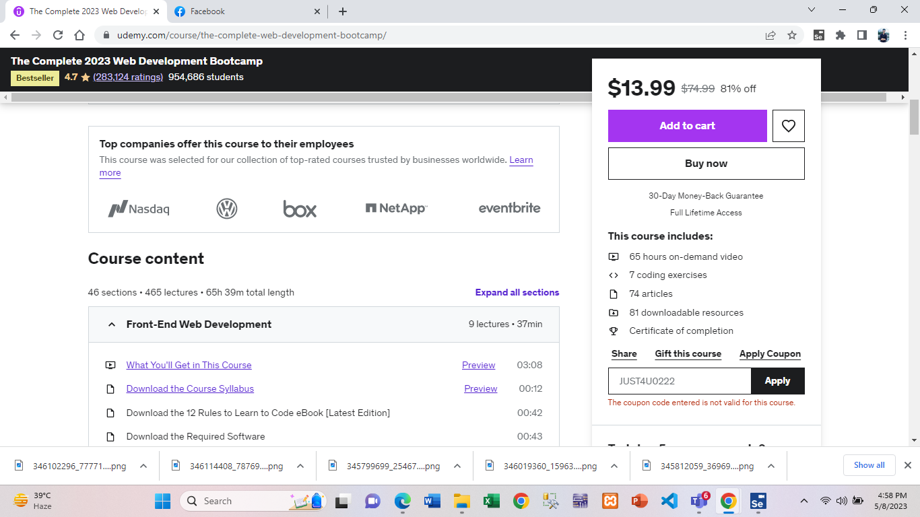

Fig : Invalid coupon test case result

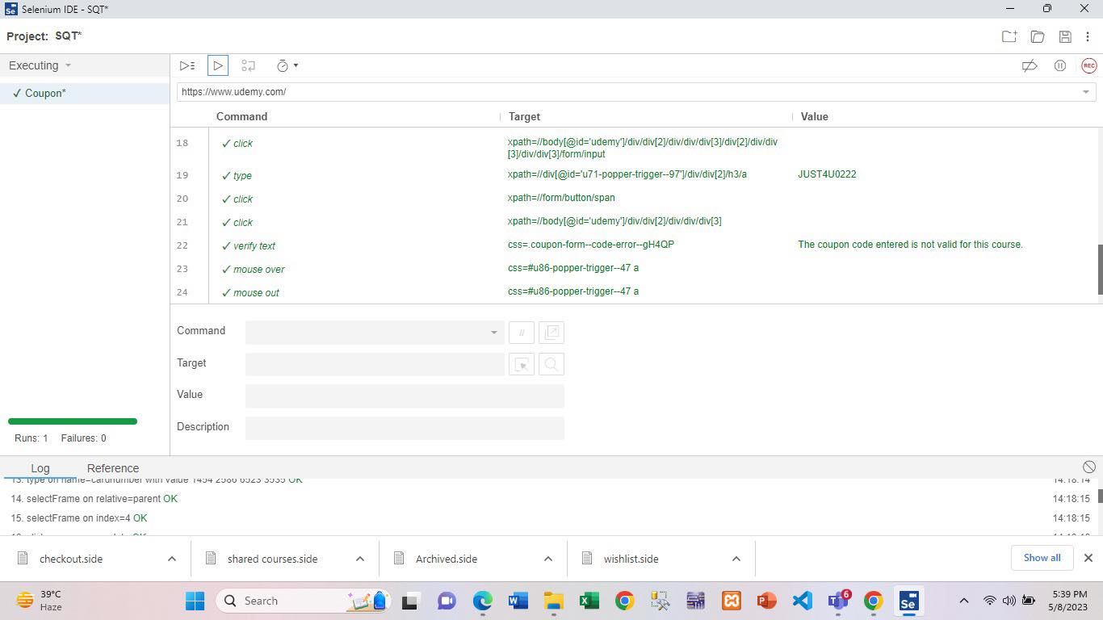

Fig : Invalid coupon test case execution

|  |  |  |  |  |  |
| --- | --- | --- | --- | --- | --- |
| Project Name: Udemy | | | Test Designed by: Md. Mehedi Hassan Shohan | | |
| Test Case ID: UDM-04 | | | Test Designed date: 08/05/2023 | | |
| Test Priority (Low, Medium, High): High | | | Test Executed by: Md. Mehedi Hassan Shohan | | |
| Module Name: Changing Language | | | Test Execution date: 08/05/2023 | | |
| Test Title: Changing the website language | | |  | | |
| Description: Test whether the system can change the language properly . | | |  | | |
| Precondition (If any): User have to signed into the Udemy account for Changing the website language | | | | | |
| Test Steps   1. Go to the udemy website 2. Scroll down in the site 3. Click on language option 4. Choose the language 5. Click on the selected language | Test Data  Mobile Number : 01864348314 | Expected Results  After changing the language user will be see the  new language in the website . . | | Actual Results  As Expected | Status  (Pass/Fail)  Pass |
|  |  |  | |  |  |
| Post Condition: User will be able to see the new language . | | | | | |

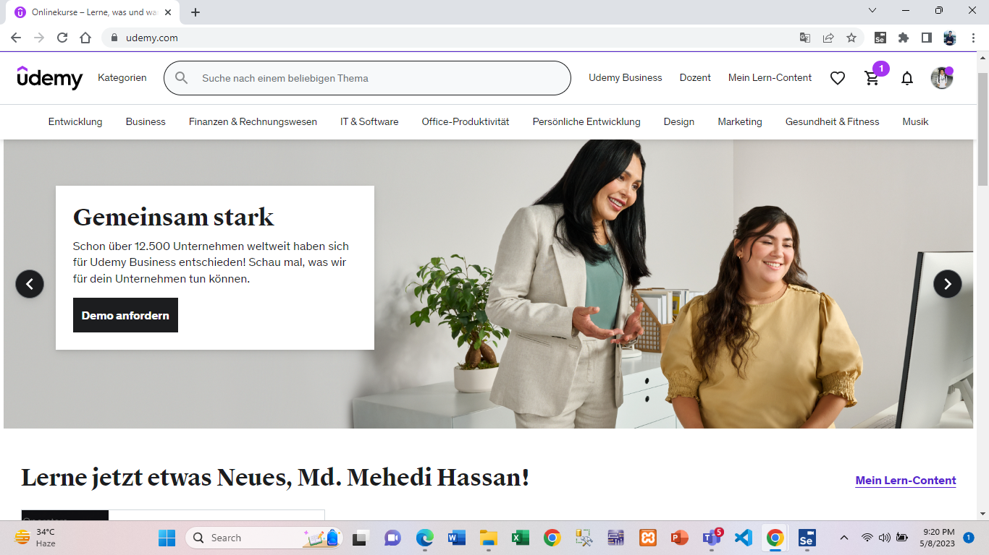

Fig : Changing language test case result

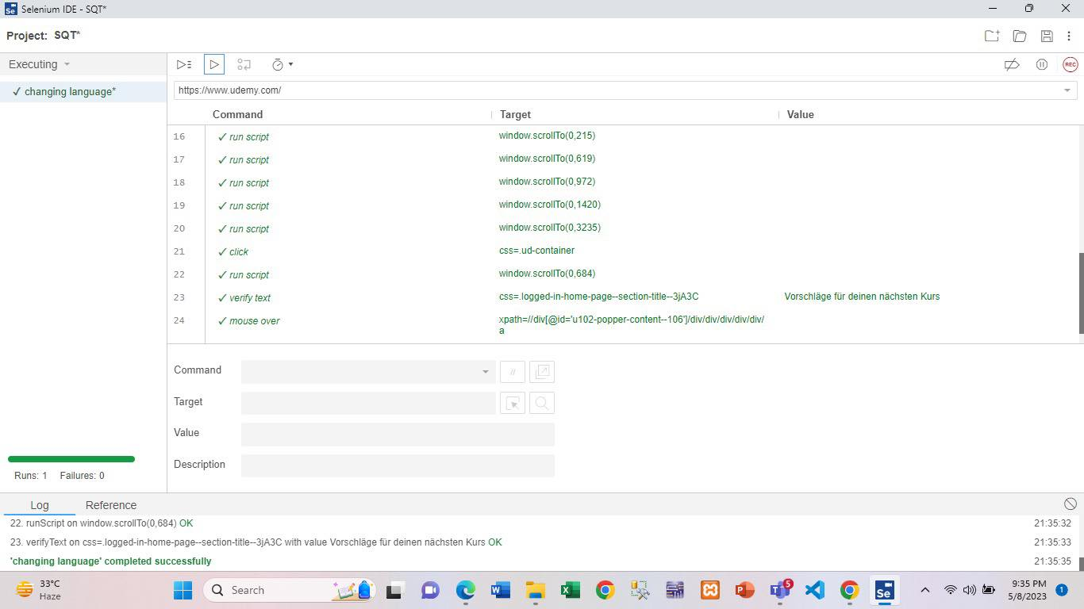

Fig : Changing language test case execution

|  |  |  |  |  |  |
| --- | --- | --- | --- | --- | --- |
| Project Name: Udemy | | | Test Designed by: Md. Mehedi Hassan Shohan | | |
| Test Case ID: UDM-05 | | | Test Designed date: 08/05/2023 | | |
| Test Priority (Low, Medium, High): High | | | Test Executed by: Md. Mehedi Hassan Shohan | | |
| Module Name: Checkout | | | Test Execution date: 08/05/2023 | | |
| Test Title: Checkout with invalid card details | | |  | | |
| Description: Test whether the user can checkout giving invalid card details . | | |  | | |
| Precondition (If any): User have to signed into the Udemy account . | | | | | |
| Test Steps | Test Data | Expected Results | | Actual Results | Status  (Pass/Fail) |
| 1. Go to the udemy website 2. Select a course 3. Click on Buy now 4. Select the Country 5. Select the payment method 6. Type card name 7. Type invalid card number 8. Type expiry date and cvc 9. Click on complete checkout. | Mobile Number:  01864348314 | User can not take checkout giving  invalid card information. | | As expected, | Pass |
| Post Condition: User have to fill all the option . | | | | | |

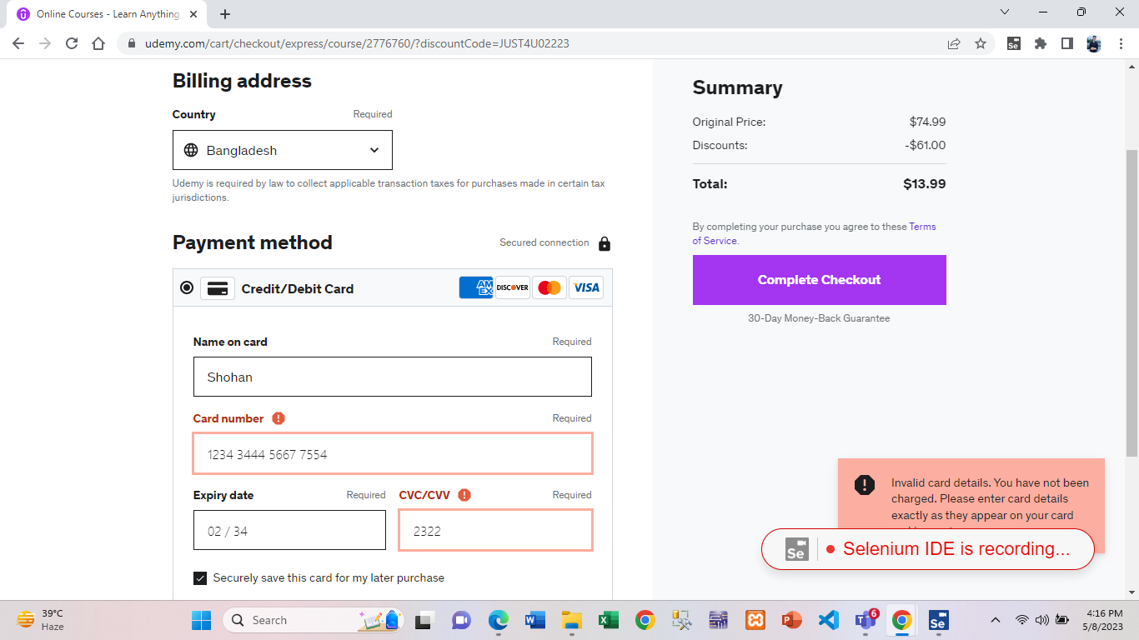

Fig : Checkout test case result

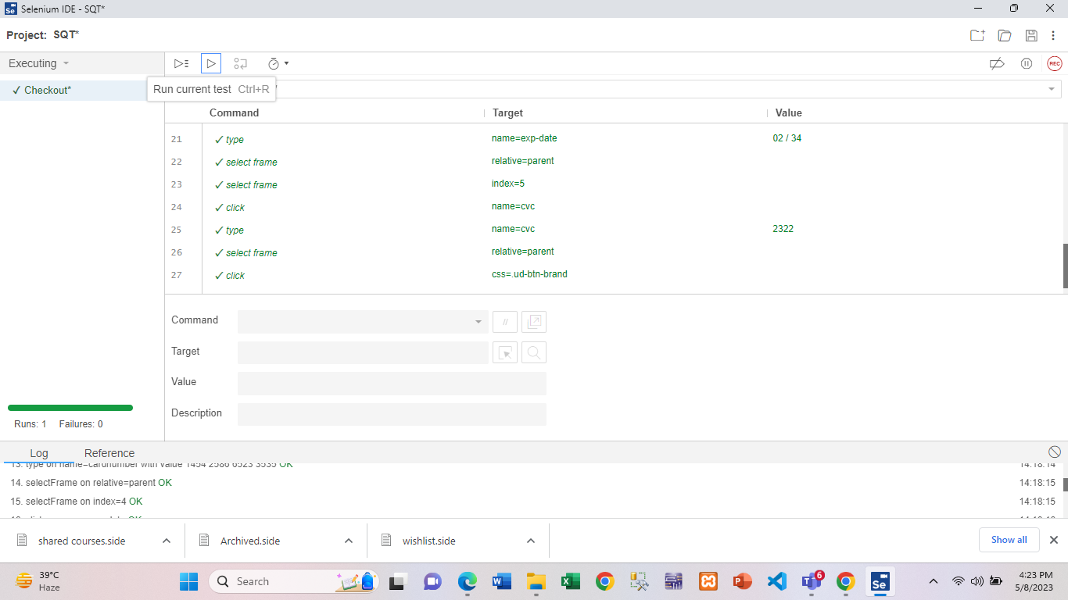

Fig : Checkout test case execution

|  |  |  |  |  |  |
| --- | --- | --- | --- | --- | --- |
| Project Name: Udemy | | | Test Designed by: Md. Mehedi Hassan Shohan | | |
| Test Case ID: UDM-6 | | | Test Designed date: 08/05/2023 | | |
| Test Priority (Low, Medium, High): High | | | Test Executed by: Md. Mehedi Hassan Shohan | | |
| Module Name: Review | | | Test Execution date: 08/05/2023 | | |
| Test Title: Check to give review | | |  | | |
| Description: Test whether the user give the course review properly . | | |  | | |
| Precondition (If any): User have to watched a course a video first . | | | | | |
| Test Steps | Test Data | Expected Results | | Actual Results | Status  (Pass/Fail) |
| 1. Go to the Udemy website 2. Click on My learning 3. Click on All courses 4. Select a course 5. Click on play button 6. Watched the video 7. Click on leave a review button 8. Give ratings using star 9. Type the experience 10. Click on Save & Exit | Mobile Number:  01864348314 | User can give ratings and share the experience with others . | | As expected, | Pass |
| Post Condition: User must have to click on save button after giving his review on that site. | | | | | |

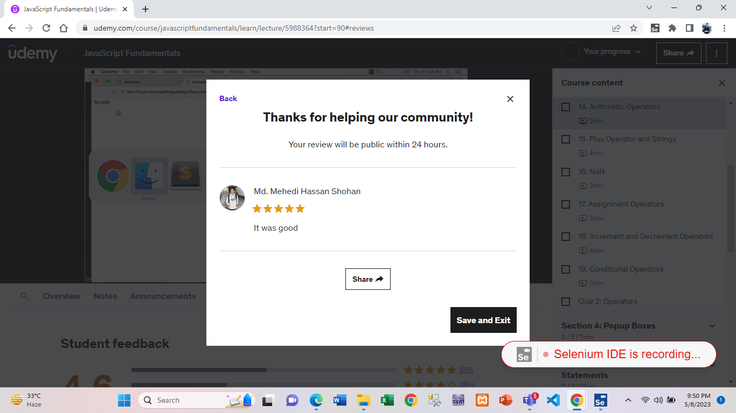

Fig : Give review test case result

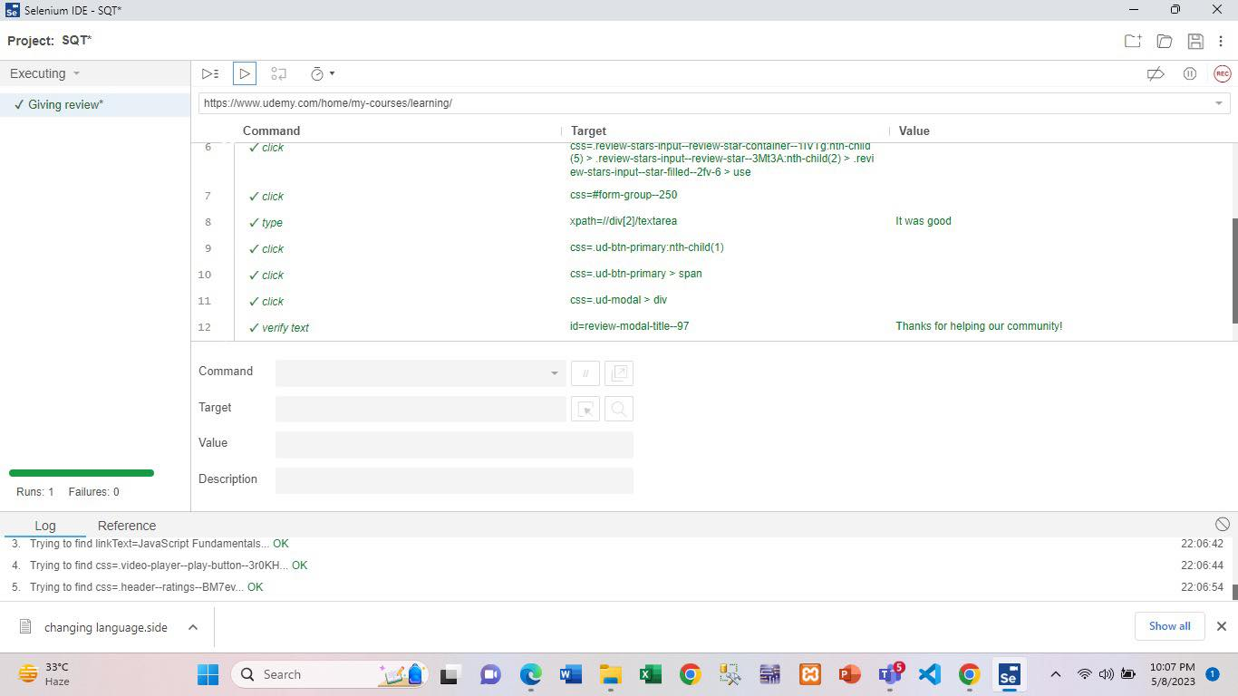

Fig : Give review test case execution

|  |  |  |  |  |  |
| --- | --- | --- | --- | --- | --- |
| Project Name: Udemy | | | Test Designed by: Md. Mehedi Hassan Shohan | | |
| Test Case ID: UDM-07 | | | Test Designed date: 08/05/2023 | | |
| Test Priority (Low, Medium, High): High | | | Test Executed by: Md. Mehedi Hassan Shohan | | |
| Module Name: Shared Courses | | | Test Execution date: 08/05/2023 | | |
| Test Title: Check to share the courses with others | | |  | | |
| Description: Test whether the user can share the course with others. | | |  | | |
| Precondition (If any): User have to signed into the Udemy account . | | | | | |
| Test Steps | Test Data | Expected Results | | Actual Results | Status  (Pass/Fail) |
| 1. Go to the Udemy website 2. Click on My learning 3. Click on All courses 4. Select the course 5. Click on share option 6. Select the way (Email, facebook ,Twitter) 7. Write the email address 8. Click on Send. | Mobile Number:  01864348314 | User can share the course with others . | | As expected, | Pass |
| Post Condition: User have to select the way how he want to send the course . | | | | | |

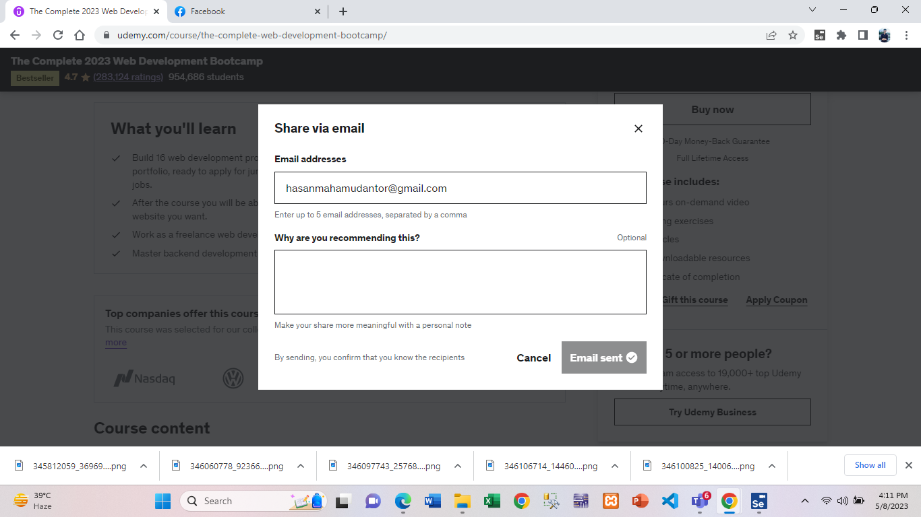

Fig : Shared courses test result

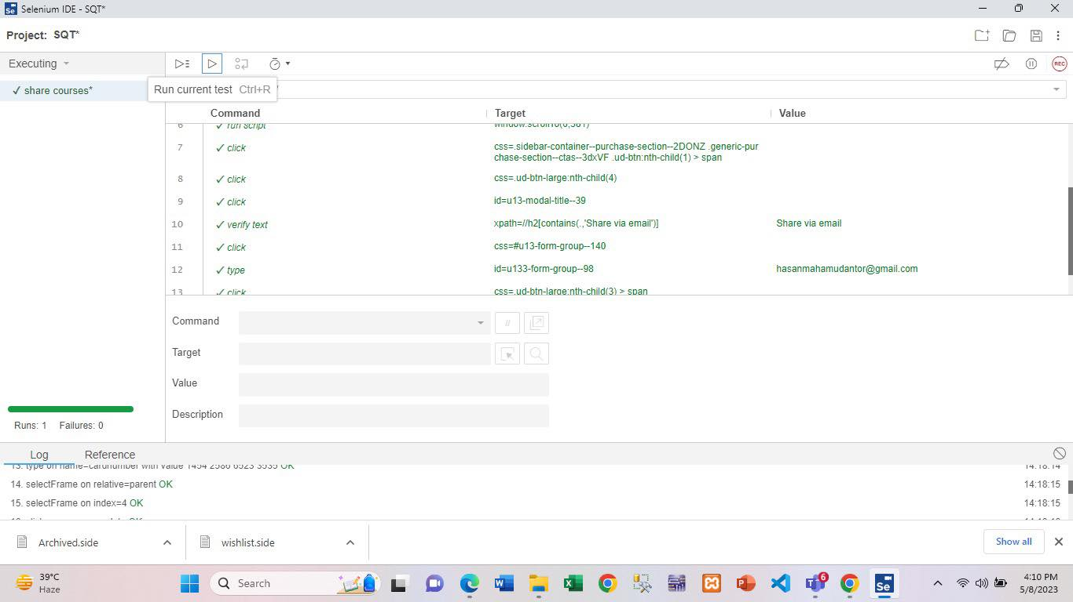

Fig : Shared courses test execution

|  |  |  |  |  |  |
| --- | --- | --- | --- | --- | --- |
| Project Name: Udemy | | | Test Designed by: Md. Mehedi Hassan Shohan | | |
| Test Case ID: UDM-08 | | | Test Designed date: 08/05/2023 | | |
| Test Priority (Low, Medium, High): High | | | Test Executed by: Md. Mehedi Hassan Shohan | | |
| Module Name: Give Quiz | | | Test Execution date: 08/05/2023 | | |
| Test Title: Check to give quiz | | |  | | |
| Description: Test whether the user can give quiz properly | | |  | | |
| Precondition (If any): User have to signed into the Udemy account . | | | | | |
| Test Steps | Test Data | Expected Results | | Actual Results | Status  (Pass/Fail) |
| 1. Go to the Udemy website 2. Click on My learning 3. Click on All courses 4. Select the course 5. Click on course content 6. Select the quiz 7. Click on start quiz 8. Select the answer 9. Click on check result 10. Click on Continue | Mobile Number:  01864348314 | User can give a quiz  On a given topic . | | As expected, | Pass |
| Post Condition: User will see the result after giving quiz . | | | | | |

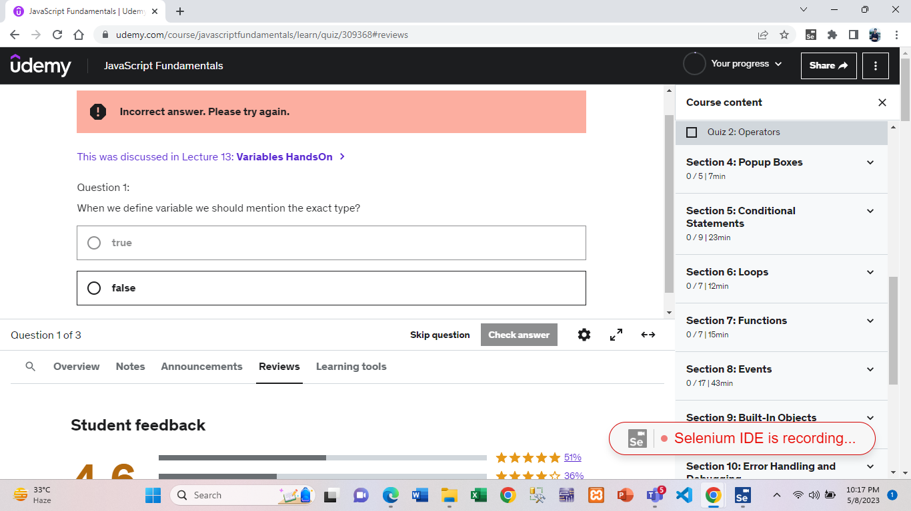

Fig : Give quiz test result

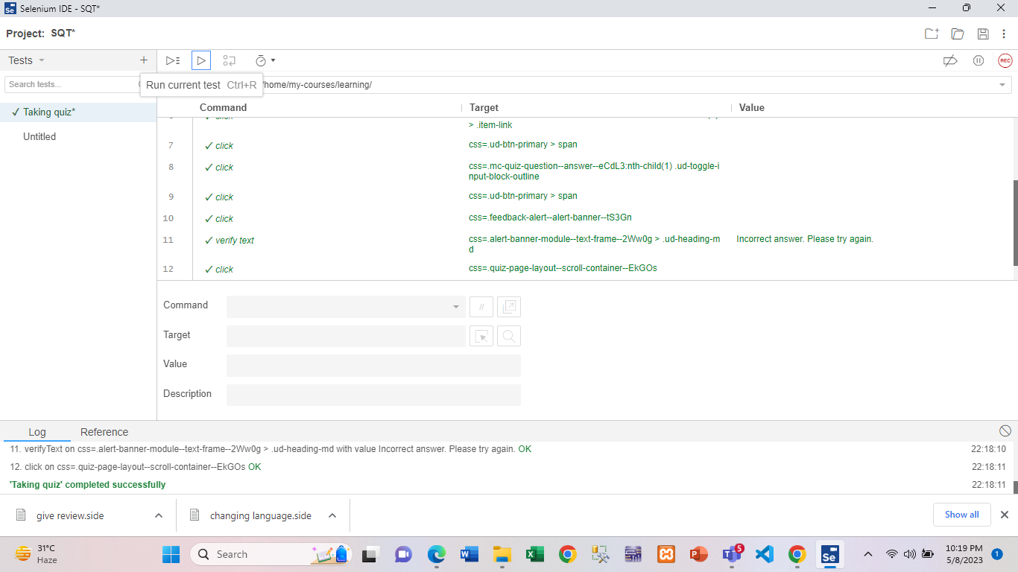

Fig : Give quiz test execution

|  |  |  |  |  |  |
| --- | --- | --- | --- | --- | --- |
| Project Name: Udemy | | | Test Designed by: Md. Mehedi Hassan Shohan | | |
| Test Case ID: UDM-09 | | | Test Designed date: 08/05/2023 | | |
| Test Priority (Low, Medium, High): High | | | Test Executed by: Md. Mehedi Hassan Shohan | | |
| Module Name: Archived Courses | | | Test Execution date: 08/05/2023 | | |
| Test Title: Check to archive the courses | | |  | | |
| Description: Test whether the user can archive the course . | | |  | | |
| Precondition (If any): User have to signed into the Udemy account . | | | | | |
| Test Steps | Test Data | Expected Results | | Actual Results | Status  (Pass/Fail) |
| 1. Go to the Udemy website 2. Click on My learning 3. Click on All courses 4. Select the course 5. Click on the dot option 6. Click on Archive button | Mobile Number:  01864348314 | User can archive the courses. | | As expected, | Pass |
| Post Condition: User have to select the courses before archive. | | | | | |

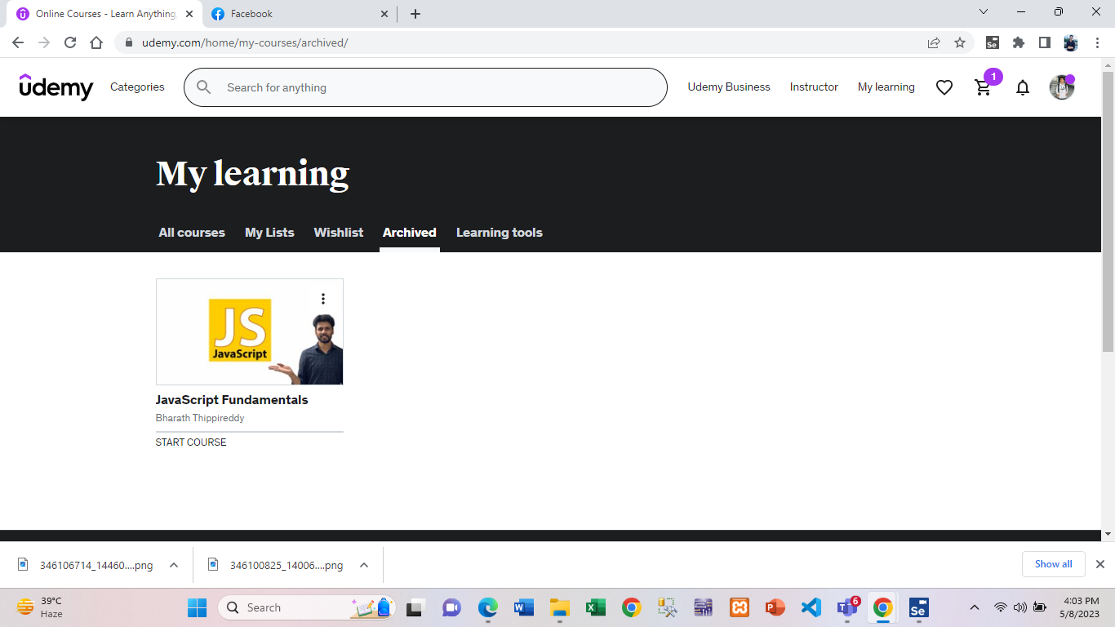

Fig : Archive courses test result

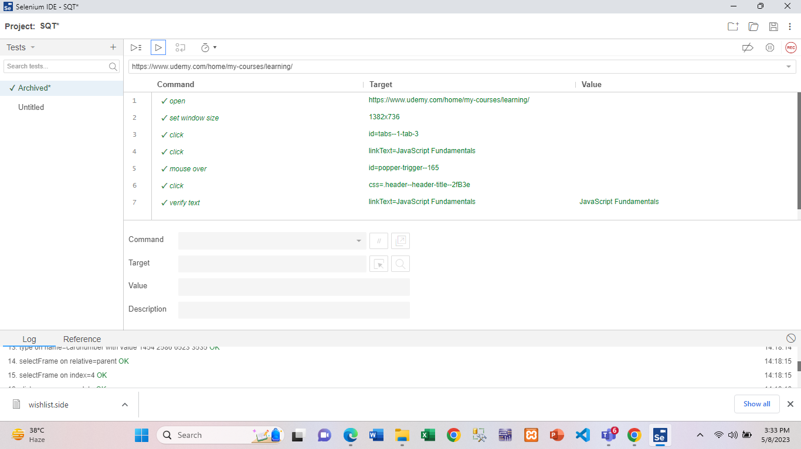

Fig : Archive courses test case execution

|  |  |  |  |  |  |
| --- | --- | --- | --- | --- | --- |
| Project Name: Udemy | | | Test Designed by: Md. Mehedi Hassan Shohan | | |
| Test Case ID: UDM-10 | | | Test Designed date: 08/05/2023 | | |
| Test Priority (Low, Medium, High): High | | | Test Executed by: Md. Mehedi Hassan Shohan | | |
| Module Name: My learning | | | Test Execution date: 08/05/2023 | | |
| Test Title: Check to my learning all the tools | | |  | | |
| Description: Test whether the user use all the options in my learning | | |  | | |
| Precondition (If any): User have to signed into the Udemy account . | | | | | |
| Test Steps | Test Data | Expected Results | | Actual Results | Status  (Pass/Fail) |
| 1. Go to the Udemy website 2. Click on My learning 3. Click on All courses 4. Select the course 5. Click on Archive 6. Click on wishlist 7. Click on learning tools 8. Make the schedule | Mobile Number:  01864348314 | User can use all the options in my learning . | | As expected, | Pass |
| Post Condition: User have to check all the options on my learning | | | | | |

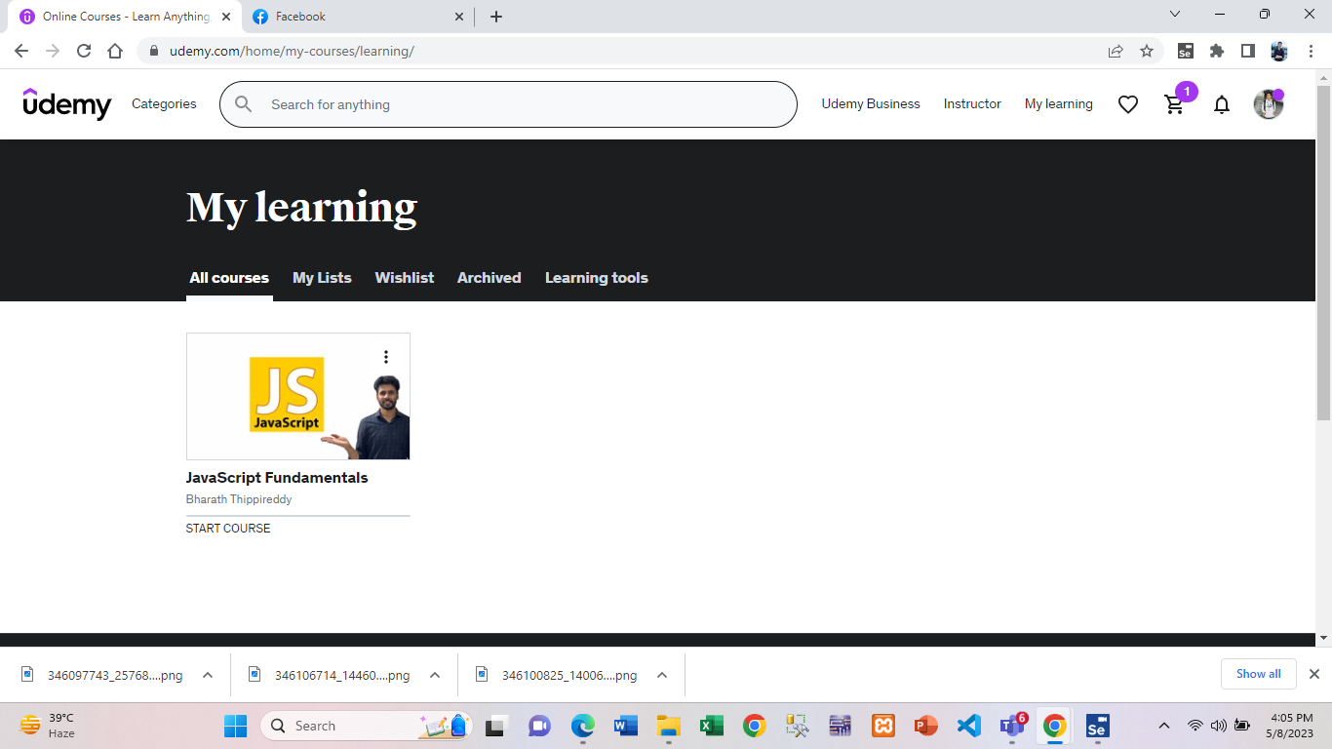

Fig : select the course result on my learning



Fig : Archive result on my learning



Fig : Schedule learn time result on my learning

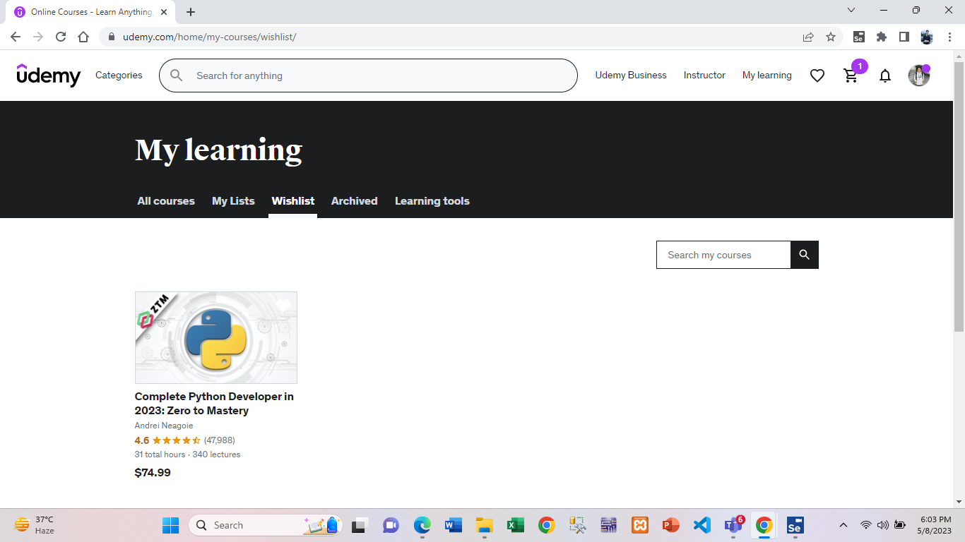

Fig : wishlist result on my learning

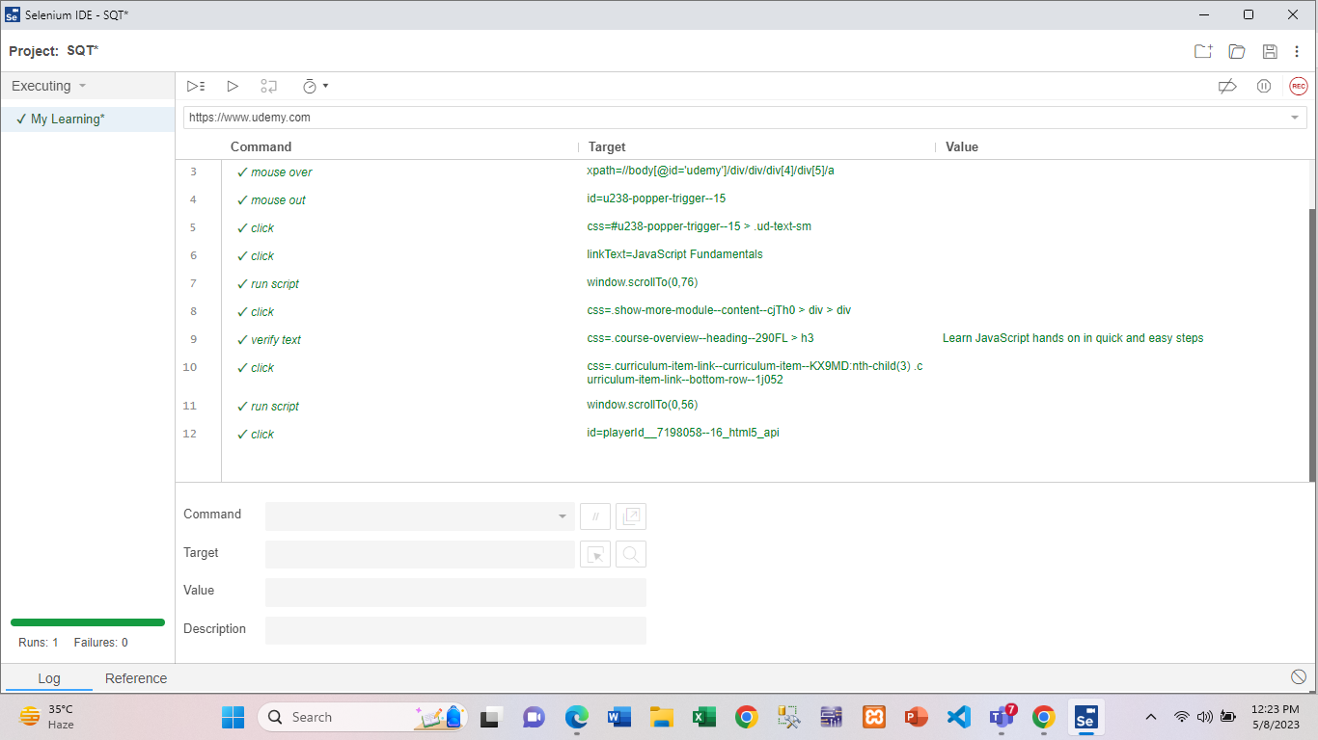

Fig : My learning test case execution

|  |  |  |  |  |  |
| --- | --- | --- | --- | --- | --- |
| Project Name: Udemy | | | Test Designed by: Md. Mehedi Hassan Shohan | | |
| Test Case ID: UDM-11 | | | Test Designed date: 08/05/2023 | | |
| Test Priority (Low, Medium, High): High | | | Test Executed by: Md. Mehedi Hassan Shohan | | |
| Module Name: Wishlist | | | Test Execution date: 08/05/2023 | | |
| Test Title: Check wishlist | | |  | | |
| Description: Test whether the wishlist work properly | | |  | | |
| Precondition (If any): User have to signed into the Udemy account . | | | | | |
| Test Steps | Test Data | Expected Results | | Actual Results | Status  (Pass/Fail) |
| 1. Go to the Udemy website 2. Select a course 3. Click on Add to wishlist 4. Click on my learning 5. Click on wishlist | Mobile Number:  01864348314 | User can see the wishlist whatever course user wanted to be in wishlist. | | As expected, | Pass |
| Post Condition: User will see the course on wishlist after selected the course | | | | | |



Fig : Wishlist test case result

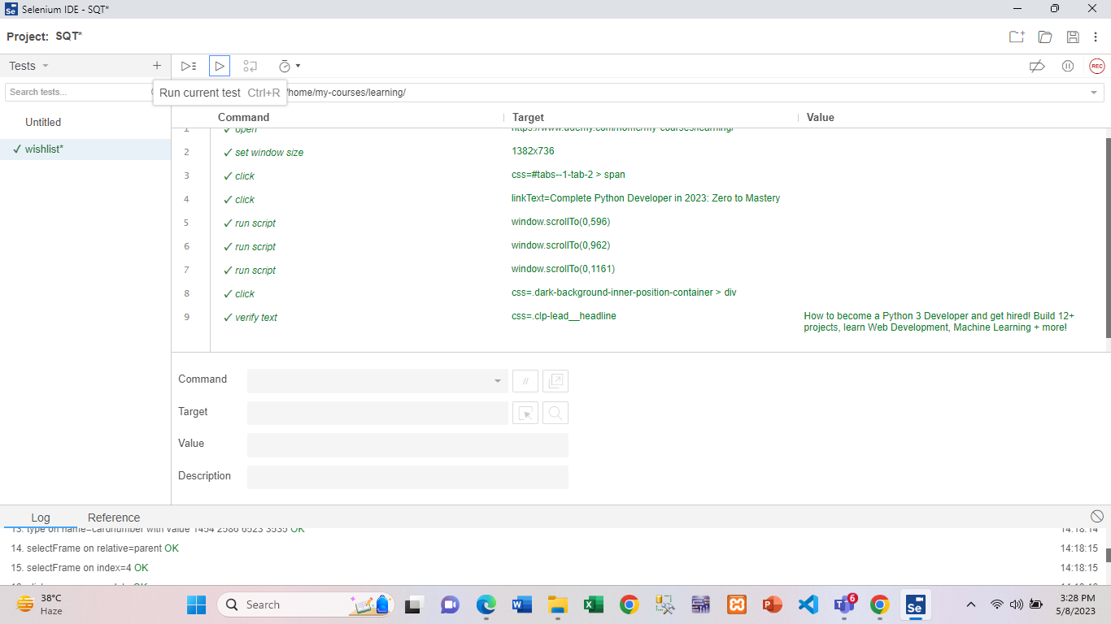

Fig : Wishlist test case execution

|  |  |  |  |  |  |
| --- | --- | --- | --- | --- | --- |
| Project Name: Udemy | | | Test Designed by: Md. Mehedi Hassan Shohan | | |
| Test Case ID: UDM-12 | | | Test Designed date: 08/05/2023 | | |
| Test Priority (Low, Medium, High): High | | | Test Executed by: Md. Mehedi Hassan Shohan | | |
| Module Name: Playing course video | | | Test Execution date: 08/05/2023 | | |
| Test Title: Check to course video | | |  | | |
| Description: Test whether the user can see the video properly | | |  | | |
| Precondition (If any): User have to signed into the Udemy account . | | | | | |
| Test Steps | Test Data | Expected Results | | Actual Results | Status  (Pass/Fail) |
| 1. Go to the Udemy website 2. Click on My learning 3. Click on All courses 4. Select the course 5. Click on course content 6. Select a content 7. Click on play button | Mobile Number:  01864348314 | User can see the video properly | | As expected, | Pass |
| Post Condition: User have to select a course content to watch the video . | | | | | |

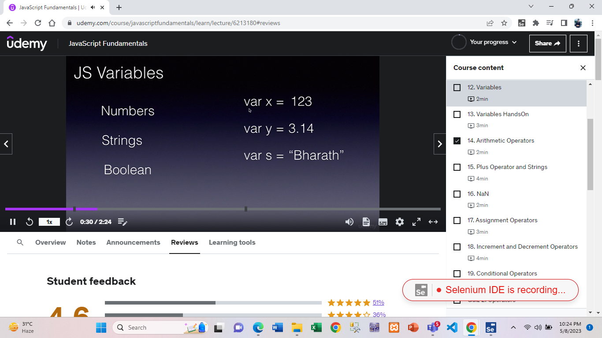

Fig : Playing course video test case result

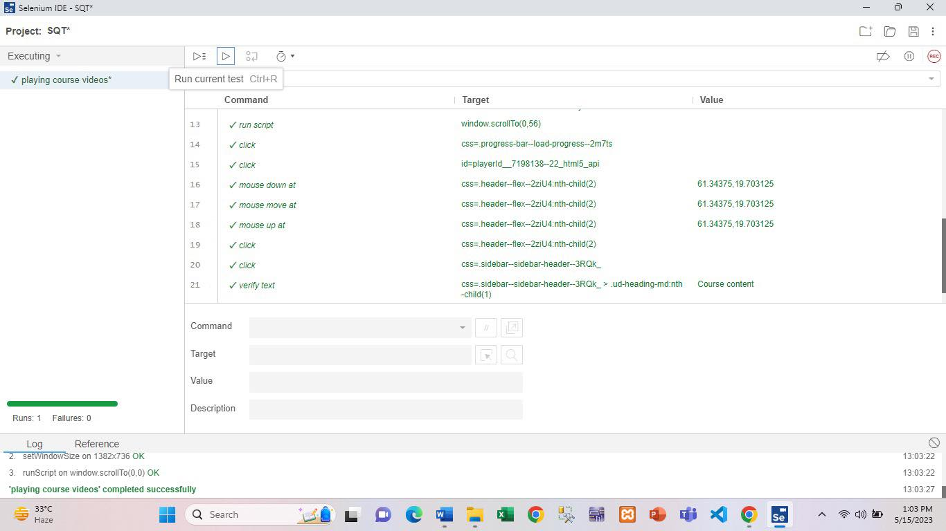

Fig : Playing course video test case execution

|  |  |  |  |  |  |
| --- | --- | --- | --- | --- | --- |
| Project Name: Udemy | | | Test Designed by: Md. Mehedi Hassan Shohan | | |
| Test Case ID: UDM-13 | | | Test Designed date: 08/05/2023 | | |
| Test Priority (Low, Medium, High): High | | | Test Executed by: Md. Mehedi Hassan Shohan | | |
| Module Name: Playback speed | | | Test Execution date: 08/05/2023 | | |
| Test Title: Check to change playback speed | | |  | | |
| Description: Test whether the user can change the playback speed of a video properly | | |  | | |
| Precondition (If any): User have to signed into the Udemy account . | | | | | |
| Test Steps | Test Data | Expected Results | | Actual Results | Status  (Pass/Fail) |
| 1. Go to the Udemy website 2. Click on My learning 3. Click on All courses 4. Select the course 5. Click on course content 6. Select a content 7. Click on play button 8. Click on playback rate 9. Select the speed | Mobile Number:  01864348314 | User can change the playback speed properly. | | As expected, | Pass |
| Post Condition: User have to select a course content to change the playback video . | | | | | |

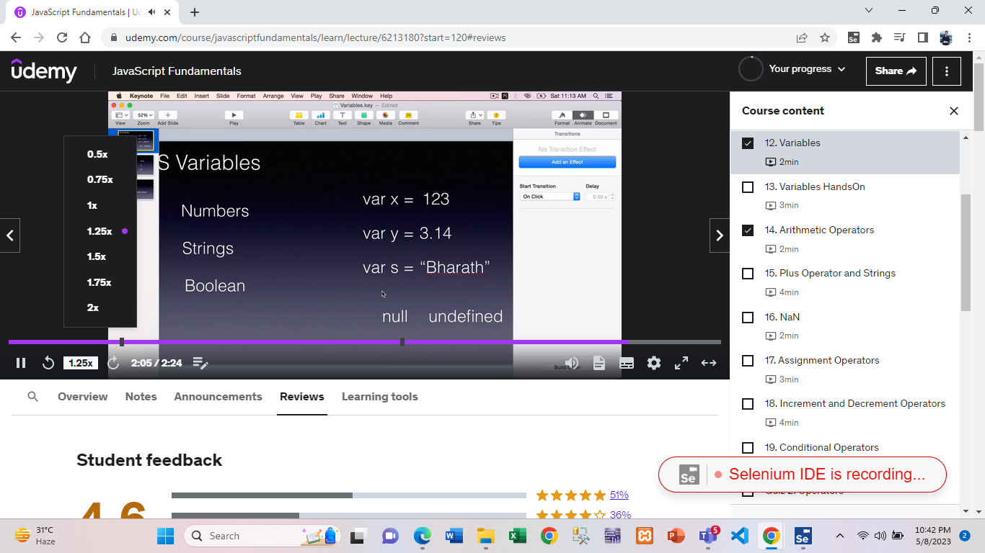

Fig : Changing playback speed test case result

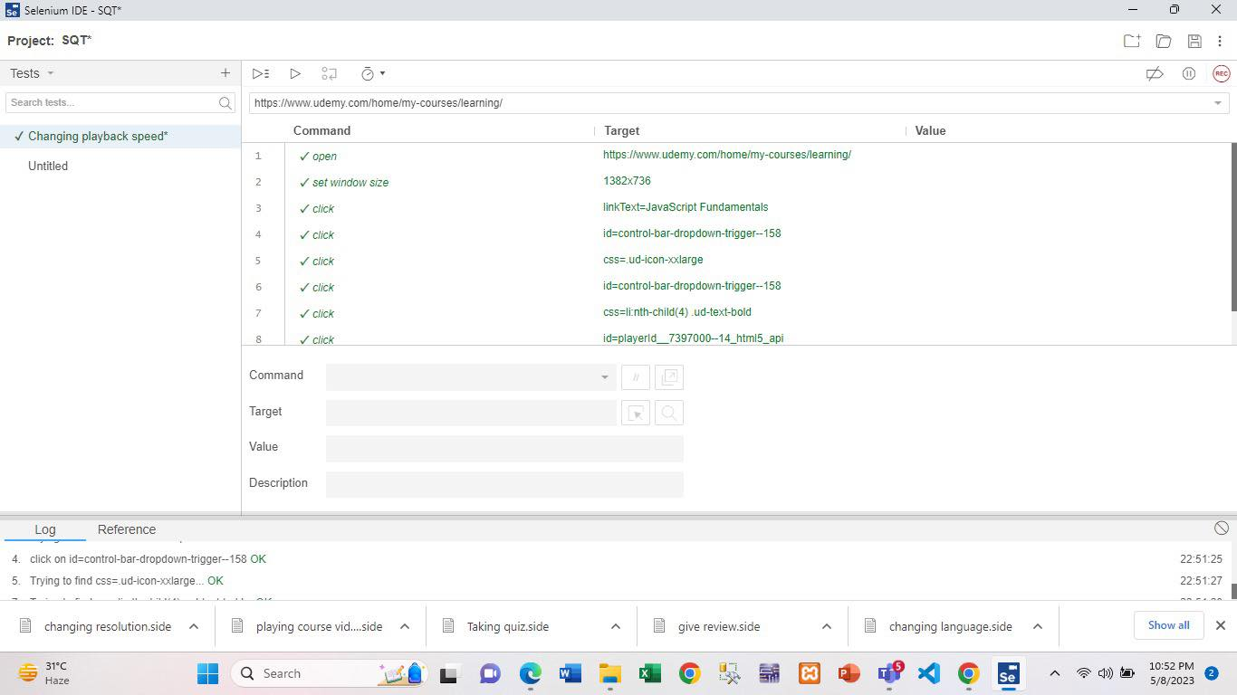

Fig : Changing playback speed test case execution

|  |  |  |  |  |  |
| --- | --- | --- | --- | --- | --- |
| Project Name: Udemy | | | Test Designed by: Md. Mehedi Hassan Shohan | | |
| Test Case ID: UDM-14 | | | Test Designed date: 08/05/2023 | | |
| Test Priority (Low, Medium, High): High | | | Test Executed by: Md. Mehedi Hassan Shohan | | |
| Module Name: Changing resolution | | | Test Execution date: 08/05/2023 | | |
| Test Title: Check to change the resolution | | |  | | |
| Description: Test whether the user can change the resolution of a video properly | | |  | | |
| Precondition (If any): User have to signed into the Udemy account . | | | | | |
| Test Steps | Test Data | Expected Results | | Actual Results | Status  (Pass/Fail) |
| 1. Go to the Udemy website 2. Click on My learning 3. Click on All courses 4. Select the course 5. Click on course content 6. Select a content 7. Click on setting button 8. Select the resolution | Mobile Number:  01864348314 | User can change the video resolution . | | As expected, | Pass |
| Post Condition: User have to select a course content to change the resolution of a video . | | | | | |

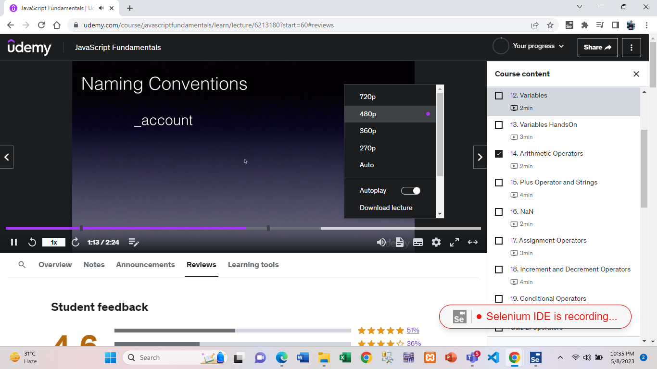

Fig : Changing resolution test case result

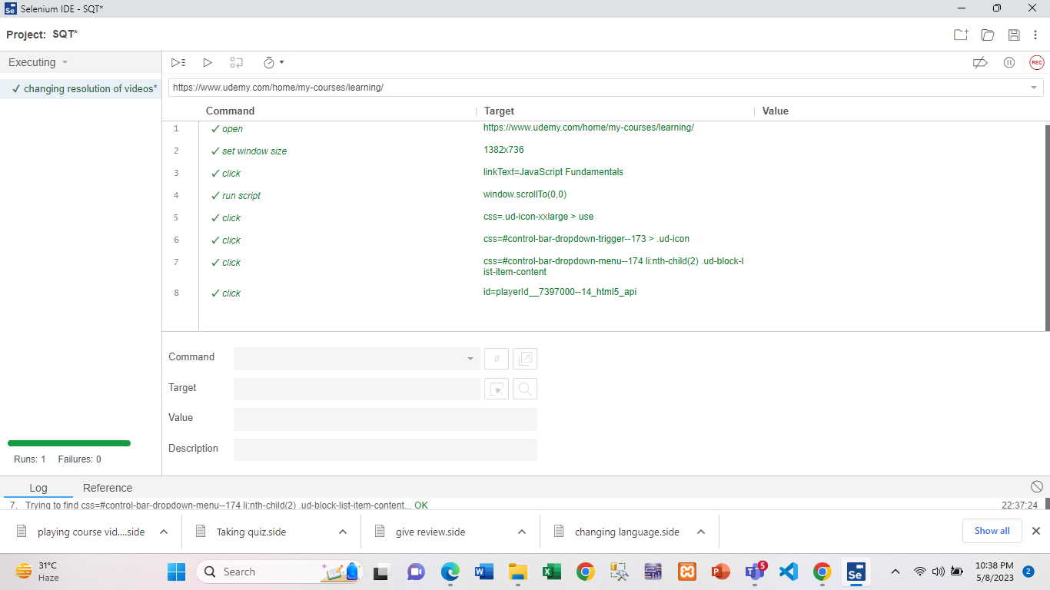

Fig : Changing resolution test case execution